- A ball of mass m1= 2kg and a block of mass m2= 5kg are attached by a lightweight cord that passes over a frictionless pulley of negligible mass, as shown in Figure-1. The block lies on a frictionless incline of angle(θ = 30⁰). Find the magnitude of the acceleration of the two objects and the tension in the cord.
- When two objects of unequal mass are hung vertically over a frictionless pulley of negligible mass, Determine the magnitude of the acceleration of the two objects and the tension in the lightweight cord. m1 = 2kg and m2 =5kg
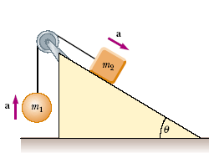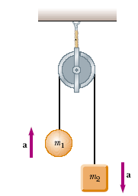
Fig-1 Fig-2
- A baseball player with mass 79kg, sliding into a base is slowed by a force of friction of 470N. What is the coefficient of kinetic friction between the player and the ground?
- The coefficient of static friction between the tires of a car and a dry road is 0.62. The mass of the car is 1500kg.What maximum braking force is obtainable (a) on a level road and (b) on an 8.6º downgrade?

- In fig # 1. “A” is a 4.4kg block and “B” is a 2.6kg block. The coefficient of static and kinetic friction between “A” and the table are 0.18 and 0.15.(a) Determine the minimum mass of the block “C” that must be placed on “A” to keep it from sliding.(b) Block “C” is suddenly lifted off “A” What is the acceleration of block “A”.
Figure#1 Figure # 2

- A worker drags a 150-lb crate across a floor by pulling on a rope inclined 17º above the horizontal. The coefficient of static friction is 0.52 and the coefficient of kinetic friction is 0.35. (a) What tension in the rope is required to start the crate moving? (b) What is the initial acceleration of the crate?

- A 42kg slab rest on a frictionless floor. A 9.7kg block rests on top of the slab as in fig #2 .The coefficient of static friction between the block an the slab is 0.53, while the coefficient of kinetic friction is 0.38.The 9.7kg block is acted on by a horizontal force of 110N. What are the resulting acceleration of (a) the block and (b) the slab?

